WEEK 2: EXPLORATORY DATA ANALYSIS AND VISUALIZATION

Name: Shreya Dolui
Internship: YuvaIntern
Dataset: Titanic Dataset

Introduction
Exploratory Data Analysis (EDA) is an important step in understanding a dataset before performing further analysis. In this task, the Titanic dataset was explored using Python to identify patterns, relationships, distributions, and important characteristics of the passengers. Pandas was used for data handling and analysis, while Matplotlib and Seaborn were used to create visualizations. The analysis focuses on passenger survival and its relationship with factors such as gender, passenger class, age, fare, and family-related variables.
Objective
The objective of this task is to perform Exploratory Data Analysis on the Titanic dataset and extract meaningful insights from the available passenger information. The analysis aims to understand the structure and quality of the dataset, identify missing values and duplicates, examine statistical characteristics, investigate factors related to passenger survival, and create meaningful visualizations to communicate the findings clearly.

Dataset Description
The main dataset used was: train.csv
Column | Description
PassengerId | Unidue passenger identifier
Survived | Survival status
Pclass | Passenger class
Name | Passenger name
Sex | Passenger gender
Age | Passenger age
SibSp | Number of siblings/spouses aboard
Parch | Number of parents/children aboard
Ticket | Ticket number
Fare | Passenger fare
Cabin | Cabin information
Embarked | Port of embarkation
Data Understanding and Preprocessing
- Dataset dimensions
- Column names
- Data types
- Missing values
- Duplicate records
- Descriptive statistics
The dataset was initially examined using Pandas functions such as head(), shape, info(), and describe(). Missing values were checked using isnull().sum(), and duplicate records were checked using duplicated().sum(). These steps helped understand the structure and quality of the dataset before performing detailed analysis.
Missing Values by Column
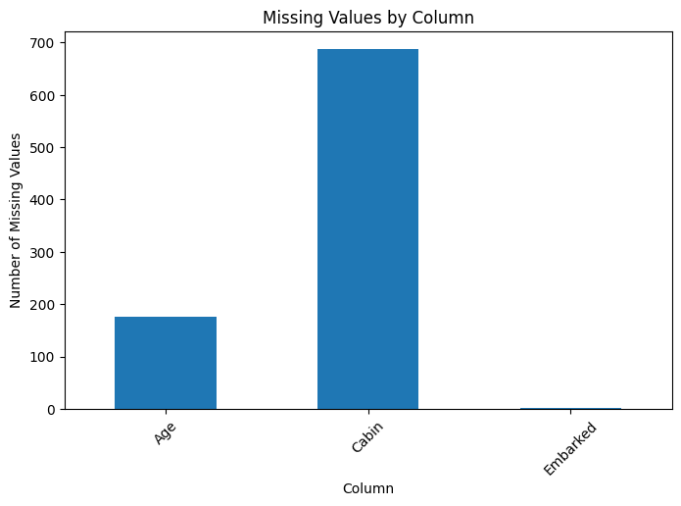
The missing values analysis was performed to identify columns containing incomplete information. The visualization shows the number of missing values present in each column of the Titanic dataset. The Cabin column contains a large number of missing values, while Age also contains missing observations. Embarked has comparatively fewer missing values. This analysis helps identify data-quality issues that should be considered before performing further analysis.
Exploratory Data Analysis
Exploratory Data Analysis (EDA) was performed to understand the main patterns, trends, and relationships present in the Titanic dataset. The analysis focused on important variables such as survival status, gender, passenger class, age, fare, and family-related information. Pandas was used for statistical analysis and data aggregation, while Matplotlib and Seaborn were used to create visualizations. The EDA helped identify factors associated with passenger survival and provided a clearer understanding of the dataset.
Data Visualizations and Interpretations
To understand the patterns and relationships present in the Titanic dataset, several visualizations were created using Matplotlib and Seaborn. The visualizations focus on survival, gender, passenger class, age, fare, family-related variables, and correlations among numerical variables. Each visualization was properly labelled with a title, axis labels, and legends where required.

Survival Distribution
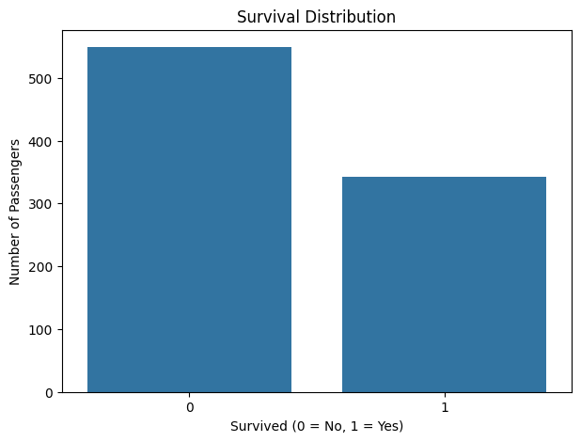
The survival distribution shows the number of passengers who survived and did not survive the Titanic disaster. The visualization indicates that the number of passengers who did not survive was higher than the number of passengers who survived. This provides an initial understanding of the overall survival pattern in the dataset.
Survival Rate by Gender
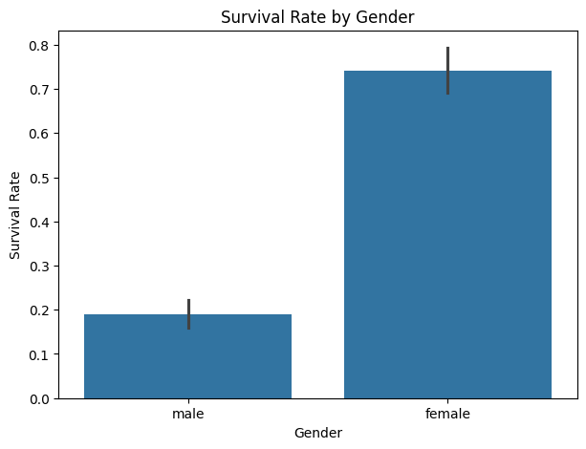
The visualization compares the survival rate of male and female passengers. It shows a clear difference in survival rates between the two groups, with female passengers having a higher survival rate than male passengers. This indicates that gender was an important factor associated with survival in the Titanic dataset.
Survival Rate by Passenger Class
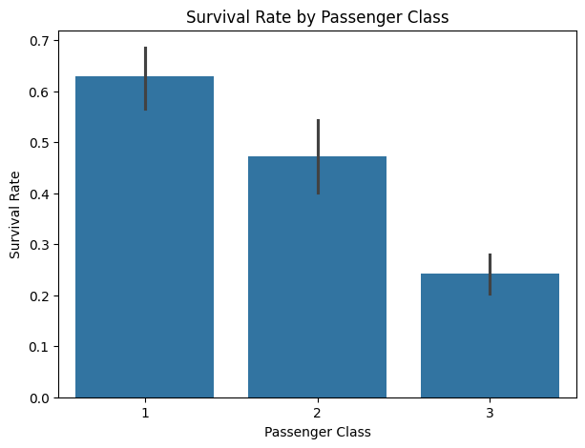
The visualization compares survival rates across the three passenger classes. The results show differences in survival rates between the classes, with passengers from higher classes generally having better survival outcomes than passengers from lower classes. This suggests that passenger class was associated with survival.
Survival Rate by Passenger Class and Gender
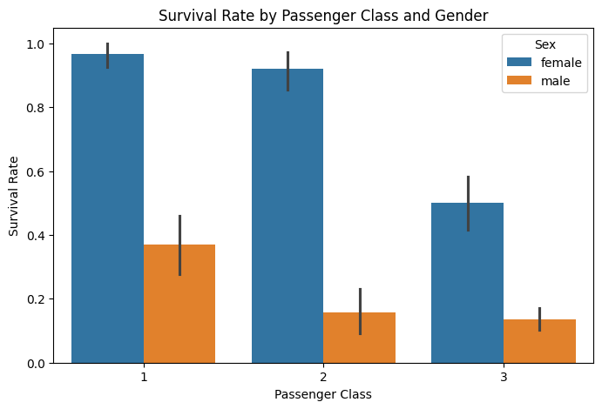
This visualization examines survival rates by considering both passenger class and gender. The comparison shows that survival patterns varied depending on both factors. Female passengers generally had higher survival rates across passenger classes, while male passengers had comparatively lower survival rates. This visualization provides a more detailed view than analyzing gender or passenger class separately.
Age Distribution
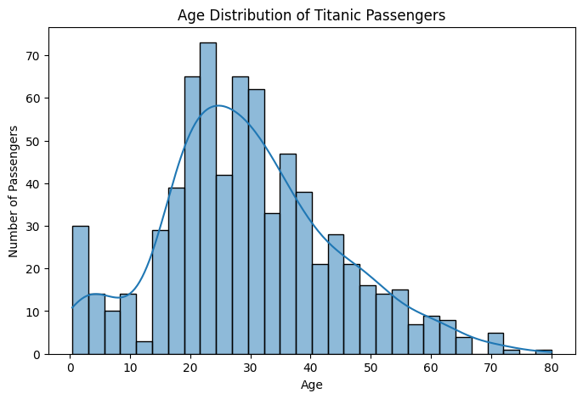
The age distribution visualization shows the spread of passenger ages in the dataset. Most passengers were concentrated within the young and middle-aged groups, while comparatively fewer passengers were present at the extreme age ranges. The distribution also highlights the presence of children and older passengers.
Fare Distribution
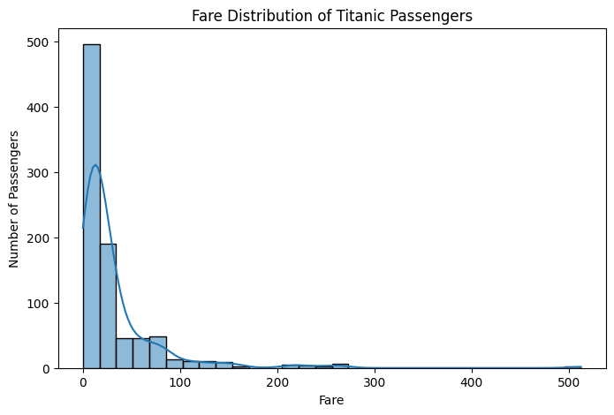
The fare distribution shows how much passengers paid for their tickets. The distribution is not uniform, as a large number of passengers paid relatively lower fares while a smaller number paid considerably higher fares. These higher values indicate variation in ticket prices among passengers.
Age Distribution by Survival
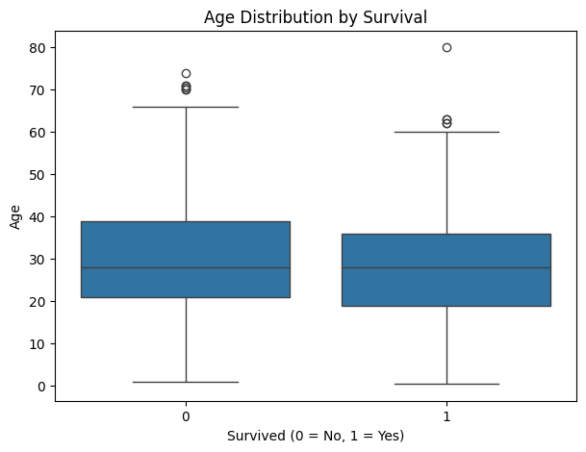
The boxplot compares the age distribution of passengers who survived with those who did not. It helps identify differences in the central tendency and spread of ages between the two groups. The visualization also shows the presence of variation and possible extreme age values within the passenger groups.
Family-Related Survival Analysis
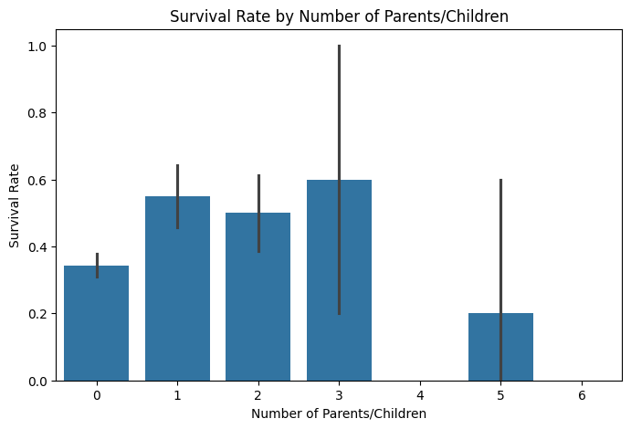
Family-related variables such as the number of siblings, spouses, parents, and children were examined to identify their relationship with survival. The visualization shows that survival rates varied according to family size. This suggests that travelling with different numbers of family members may have been associated with different survival outcomes.
Correlation Heatmap
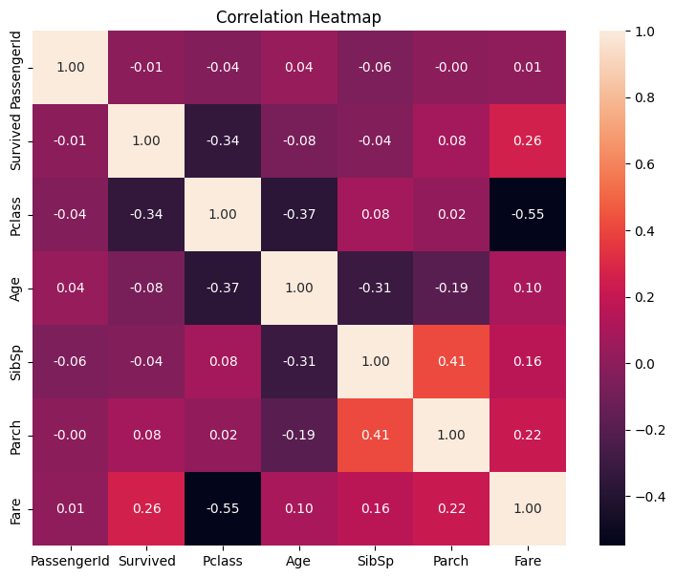
The correlation heatmap shows the relationships between the numerical variables in the Titanic dataset. The values range from negative to positive correlations, allowing relationships between variables to be identified. The heatmap provides a quick overview of which numerical variables have stronger or weaker relationships with each other and with the survival variable.
Key Findings
- The analysis revealed differences in survival outcomes across passenger groups.
- Gender showed a noticeable relationship with survival.
- Passenger class also showed differences in survival rates.
- Age and fare distributions showed variation among passengers.
- Family-related variables provided additional information about survival patterns.
- Correlation analysis helped identify relationships among numerical variables.

Data Transformations and Aggregations
The Titanic dataset was analyzed using Pandas without making unnecessary changes to the original dataset. The data was first inspected to understand its structure, data types, missing values, and duplicate records. Statistical functions were used to summarize numerical variables such as Age and Fare.
GroupBy operations were used to calculate survival rates for different passenger groups, including gender and passenger class. These aggregations helped compare the survival outcomes between different categories. Numerical columns were also selected for correlation analysis to identify relationships among numerical variables.
During the analysis, a copy of the original DataFrame was created using df.copy() so that any further analysis or transformations could be performed without directly modifying the original dataset. The visualizations were then created from the analysed data using Matplotlib and Seaborn.
The transformations and aggregations were performed to make the dataset easier to analyse and to extract meaningful patterns from the passenger information
Conclusion
The Exploratory Data Analysis of the Titanic dataset provided useful insights into passenger characteristics and survival patterns. The analysis examined variables such as gender, passenger class, age, fare, and family-related information using statistical methods and visualizations.
The results showed noticeable differences in survival rates between male and female passengers and among different passenger classes. Age and fare distributions also showed considerable variation across passengers. Family-related variables provided additional information about differences in survival outcomes. The correlation analysis helped identify relationships among the numerical variables in the dataset.
Overall, the use of Pandas, Matplotlib, and Seaborn made it possible to explore the dataset systematically and communicate the findings through clear visualizations. The analysis demonstrates how Exploratory Data Analysis can be used to identify patterns, relationships, and important characteristics within a real-world dataset.

